Articles and Reviews:
Emphasises description with longer titles
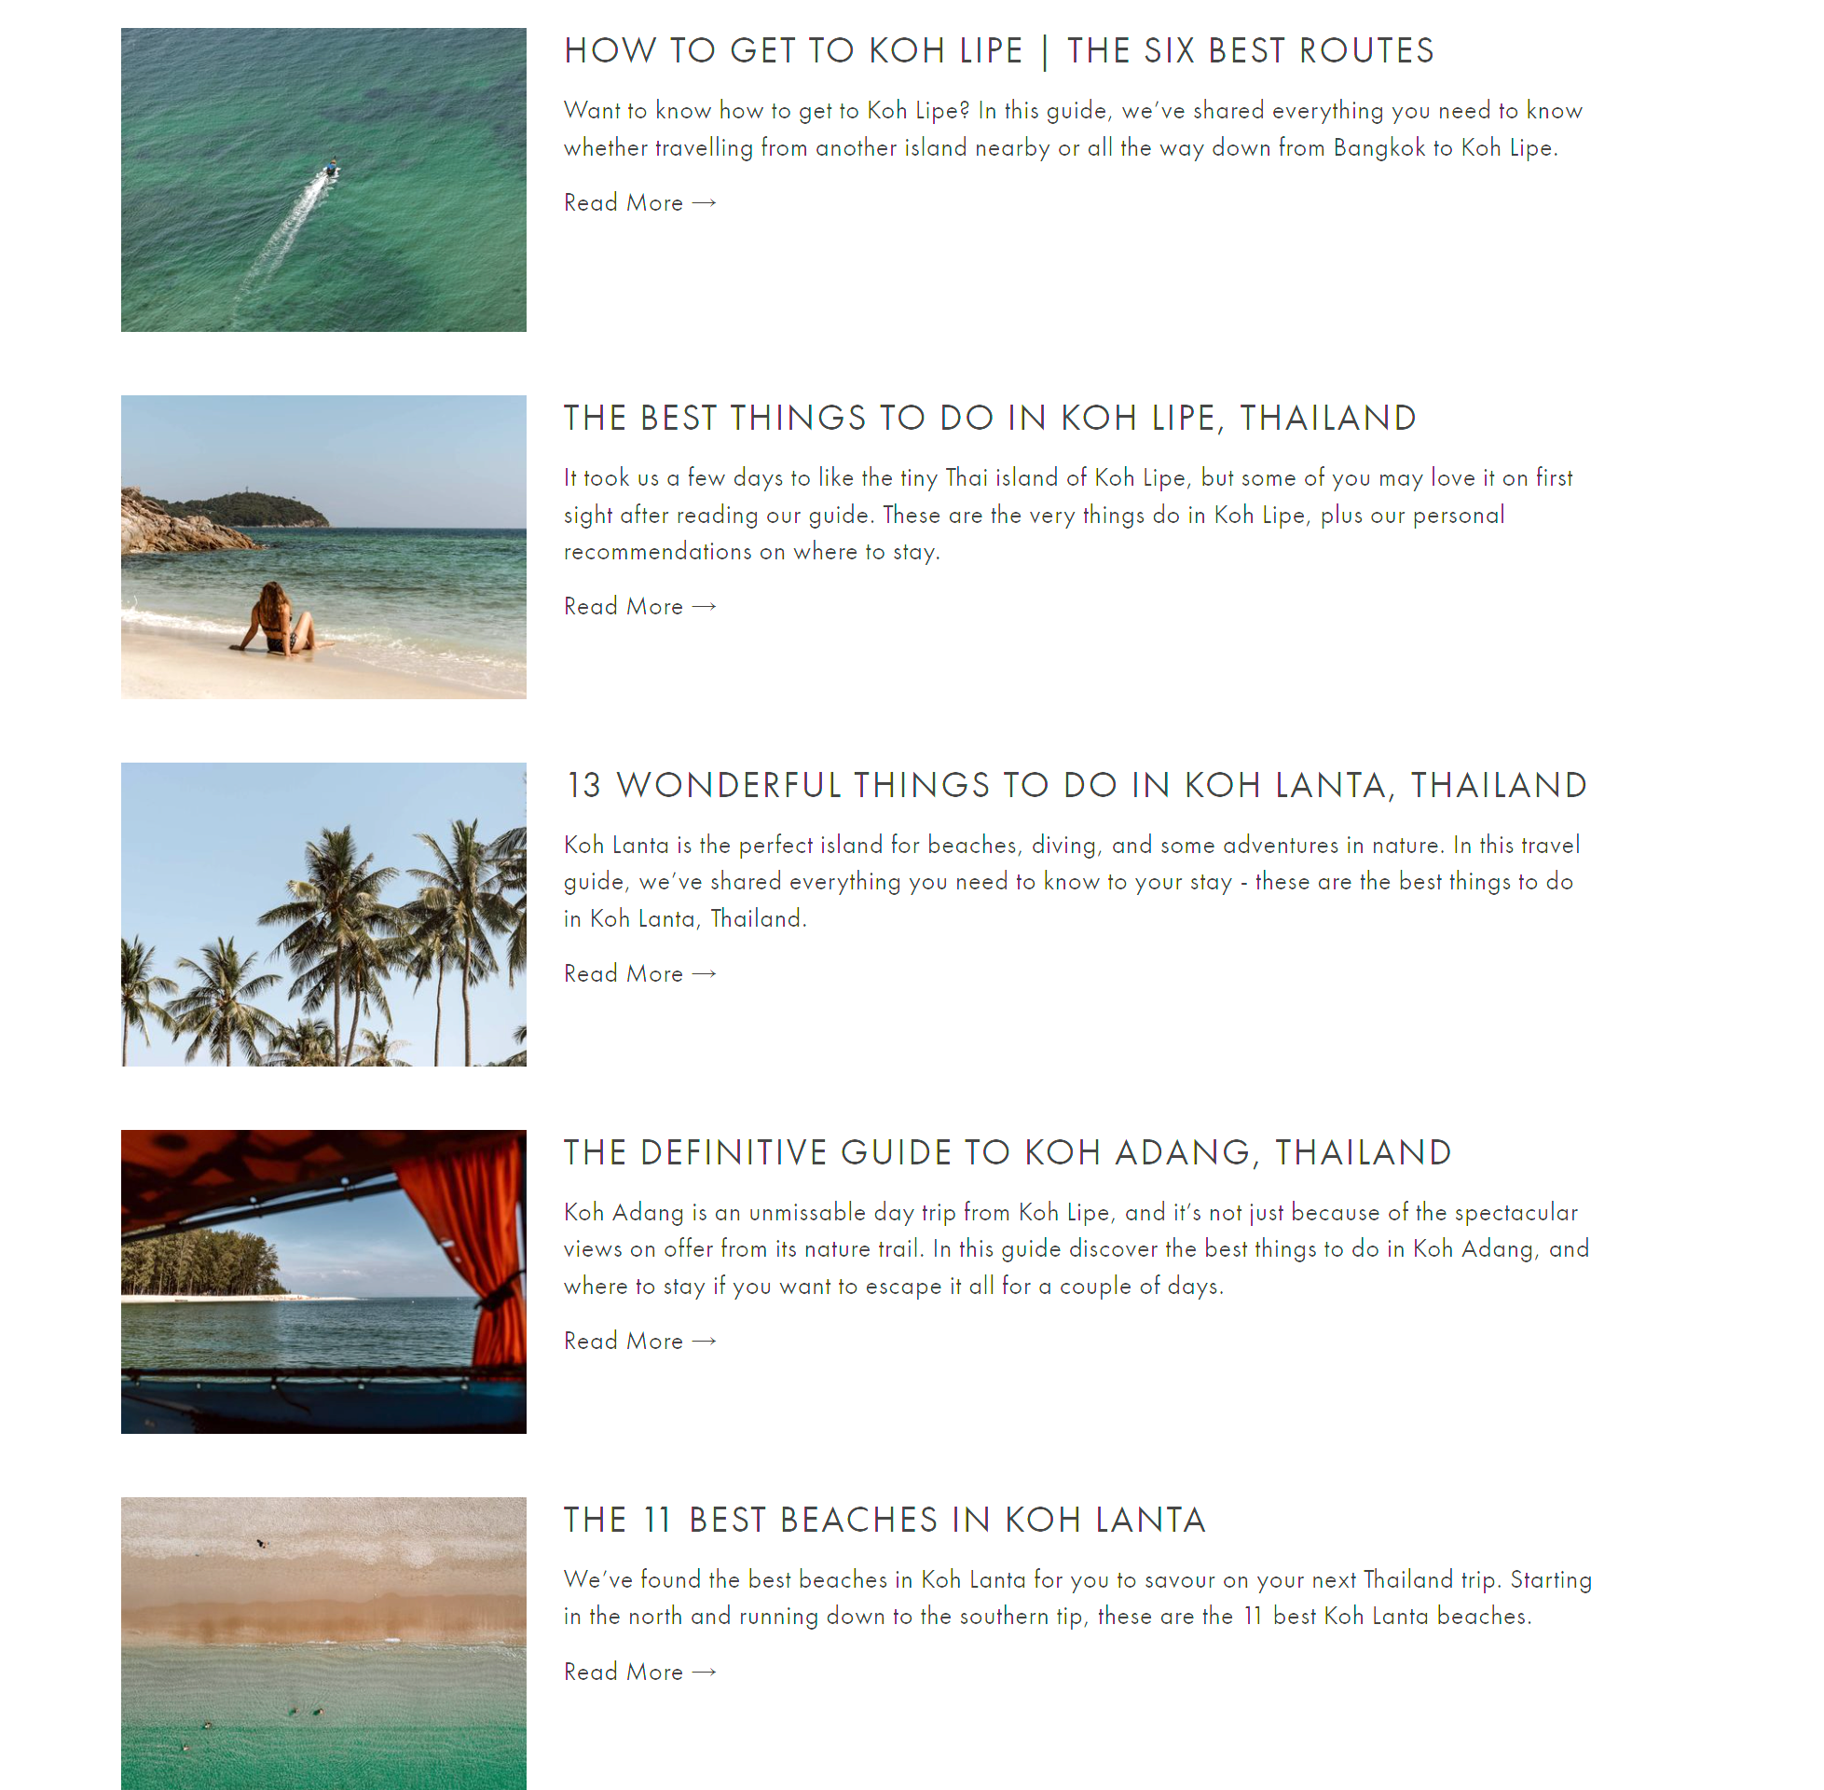

Blog:
Priorities images, with easily viewable descriptions, and short titles
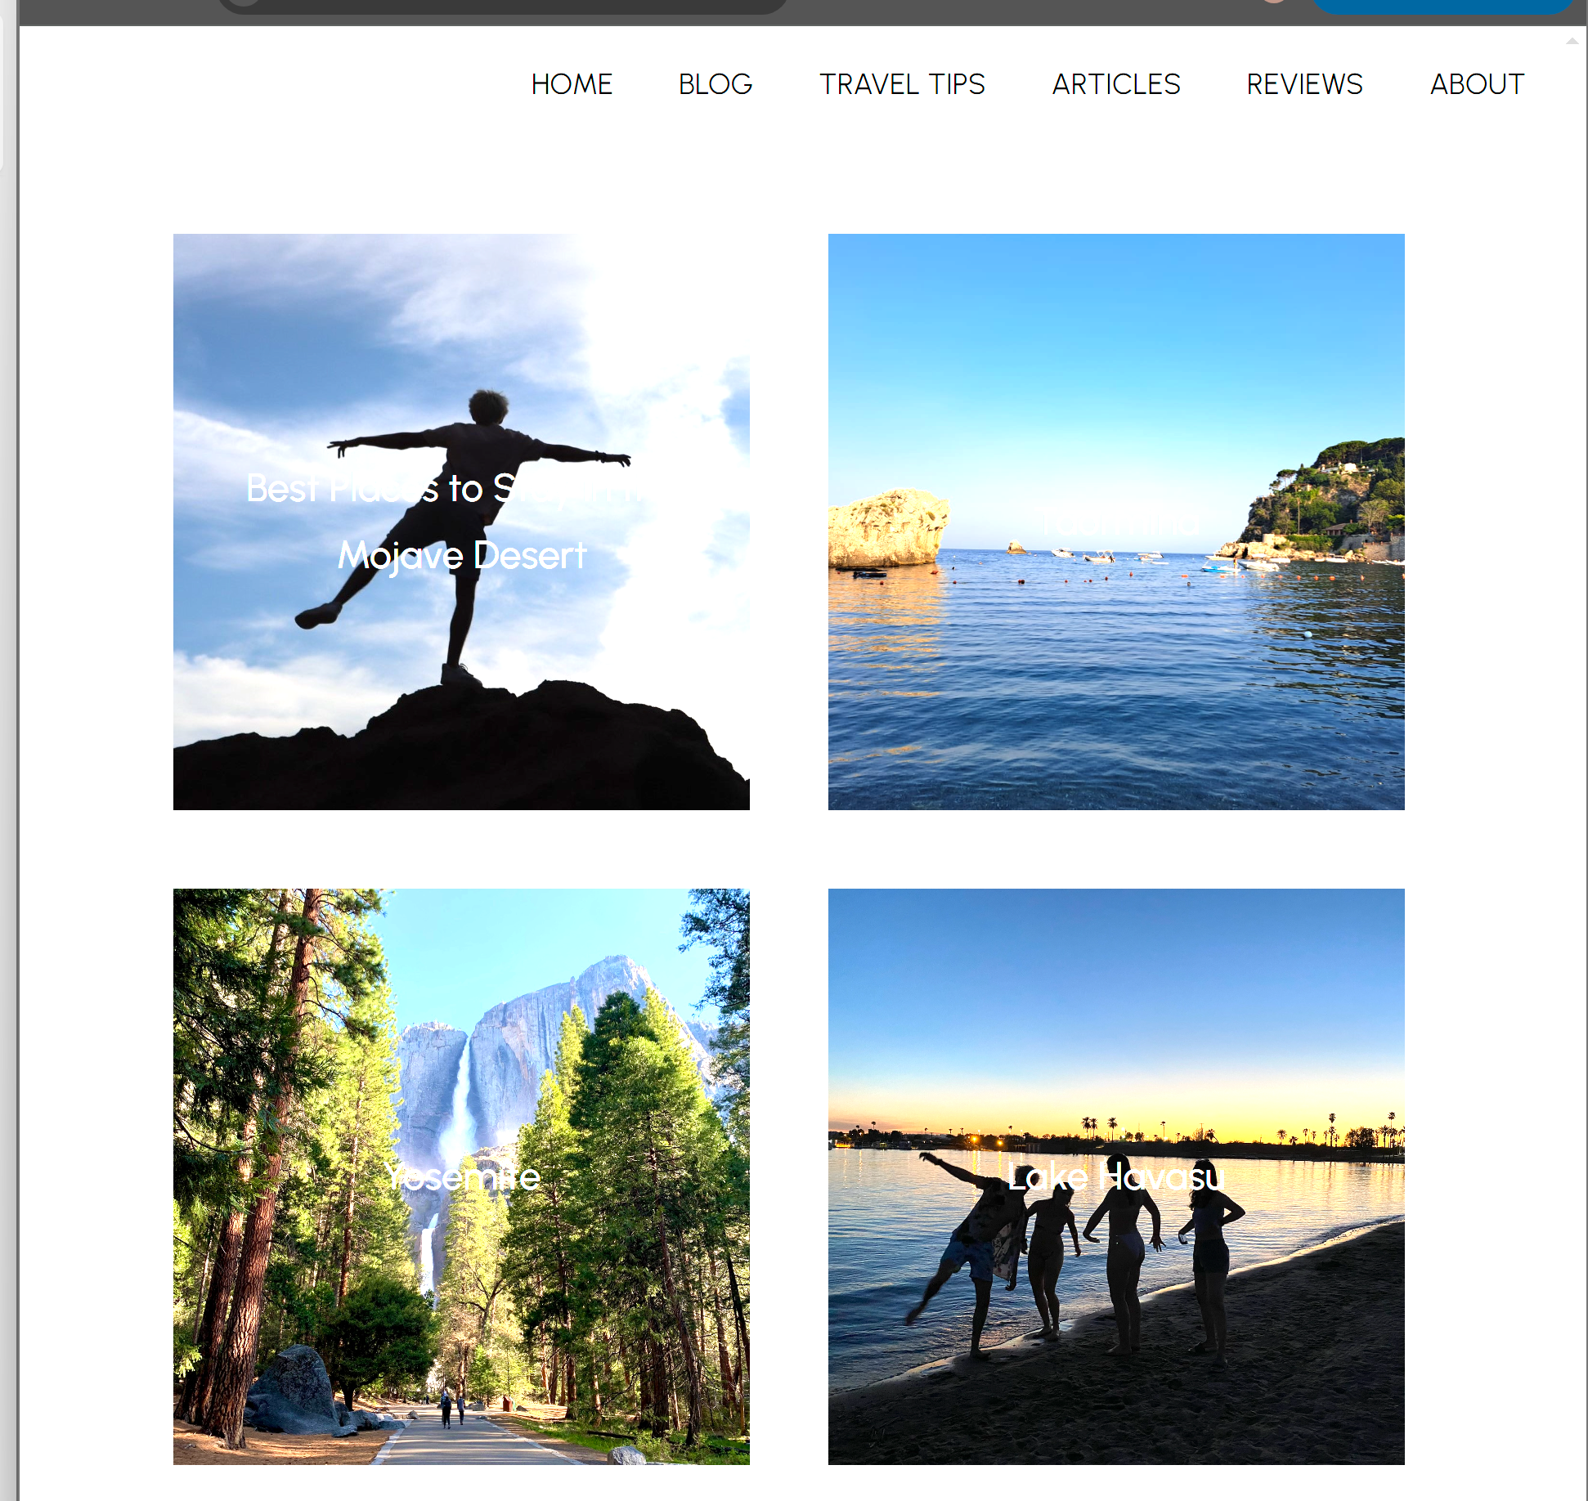

Travel Tips:
Same as blog but allow longer titles

Photography:
Minimal text, small description, short titles
Posts (photos) are non-clickable. Could still include hover for a description of location. Or could make clicking lead to full screen of the image, or take you top a shop page to buy a print of it or tshirt or other merch
